**HOSPITAL MANAGEMENT**

MINI PROJECT REPORT

Submitted by

**Krishnam Bharath [ RA2311028010016]**

Under the Guidance of

**Manickam M**

**21CSC203P** – **ADVANCED PROGRAMMING PRACTICES**

**DEPARTMENT OF COMPUTATIONAL INTELLIGENCE**



**FACULTY OF ENGINEERING AND TECHNOLOGY**

**SCHOOL OF COMPUTING**

**SRM INSTITUTE OF SCIENCE AND TECHNOLOGY**

**KATTANKULATHUR**

**NOVEMBER 2024**

**SRM INSTITUTION OF SCIENCE AND TECHNOLOGY**

**(Under Section 3 of UGC Act, 1956)**

**BONAFIDE CERTIFICATE**

Certified that the 21CSC203P Advance Programming Practice course project report titled **“HOSPITAL MANAGEMENT”** is the bonafide work done by **AKULA SONU [RA2311028010008] of IIYear/III Sem B.Tech(CSE-CC)** who carried out the mini project under my supervision.

**SIGNATURE**

**Faculty In-Charge Manickam M**

**Faculty Name**

Assistant Professor,

Department of Computational Intelligence,

SRM Institute of Science and Technology

Kattankulathur

ABSTRACT

This report will present a designing, building, and deploying a Hospital Management System employing Java programming language. The purpose of the system is to ensure seamless, effective, and organized interaction between patients, physicians and administrative employees. HMS has important features including patient enrollment, allocation of doctors, making appointments, managing bills, keeping up with medical records and controlling supplies.

The object-oriented approach of Java makes the system modular, scalable, and easy to maintain. In this system, the module is divided into multiple modules such as patient management, doctor management, appointment handling, and report generation that interact with each other with well-defined interfaces. Another important aspect of the report is how data persistence has been handled using a database backend, for example MySQL, to store patient records, doctor schedules, and billing details.

It intends to make data more accurate and less prone to manual error,

providing access to patients' data very quickly. The security feature has also been implemented with role-based access control in order to maintain privacy in the data. Testing of the system has been carried out against a lot of edge cases so that the system should work very smoothly. It is a Java-based HMS, providing an easy user interface, which shows a scope for enhancing the overall efficiency of the operations in a hospital.

**ACKNOWLEDGEMENT**

We express our heartfelt thanks to our honourable **Vice Chancellor Dr. C. MUTHAMIZHCHELVAN**, for being the beacon in all our endeavours. We would like to express my warmth of gratitude to our **Registrar Dr. S Ponnusamy,** for his encouragement.

We express our profound gratitude to our **Dean (College of Engineering andTechnology) Dr. T. V.Gopal,** for bringing out novelty in all executions.We would like to express my heartfelt thanks to Chairperson, School of Computing **Dr. Revathi Venkataraman,** for imparting confidence to complete my course project

We wish to express my sincere thanks to **Course Audit Professors Dr.Vadivu. G , Professor, Department of Data Science and Business Systems** a**nd Dr. Sasikala. E Professor, Department of Data Science and BusinessSystems** and **Course Coordinators** for their constant encouragement and support.

We are highly thankful to our Course project Faculty **Faculty Name,Assistant Professor , Department of Computational Intelligence,** for her assistance, timely suggestion and guidance throughout the duration of this course project.

We extend my gratitude to our **HOD Dr.Annie Uthra R Professor and** **Head, Department of Computational Intelligence** and my Departmental colleagues for their Support.

Finally, we thank our parents and friends near and dear ones who directly and indirectly contributed to the successful completion of our project. Above all, I thank the almighty for showering his blessings on me to complete my Course project

**INTRODUCTION**

The Hospital Management System is an all-in-one software product that manages a variety of operations carried out in a hospital right from registering a patient, booking an appointment with a physician to maintaining the medical records of patients. In this Hospital Management System, a graphical user interface developed in Java Swing is used while a MySQL database is used extensively for data storage management. Thus, this hospital management system is simple, effective and systematic in managing day to day administration of a hospital.

There are four main types of users who make use of the system: Admin, Doctor, Receptionist and the Patient and it contains specific features for each of them. Each of these user types has and performs certain roles within the hospital so that the daily operations are simplified and information remains available but is also well guarded.

For Each Role Key Features

* **Admin:**
* Can create, view, update and delete doctors, patients & receptionist records.
* Oversees appointments by managing the scheduling, and status changes.
* Can change and update the details of her/his profile and password as well.
* **Doctor:**
* Sees all the appointments that have been allocated to them.
* Can alter her/his personal profile and change password as well.
* **Receptionist:**
* Oversees patient file by accessing and changing patients’ data when necessary.
* Makes and modifies appointments to patients with the relevant doctors.
* Can change and update the details of her profile and password as well.
* **Patient:**
* Views the profiles of available doctors and the areas of specialization.
* Controls her/his own appointments by performing viewing, scheduling or updating activities.
* Can change and update the details of her profile and password as well.

**LITERATURE SURVEY**

Hospital Management Systems (HMS) enhance healthcare delivery by digitizing patient records, ensuring data accuracy, and streamlining workflows. Key recent findings include:

1. **Digital Transformation**: Digital HMSs reduce errors and enable faster access to patient data compared to paper records, which enhances decision-making and patient care (Adigun et al., 2023).
2. **Database Use**: Relational databases like MySQL allow for efficient data storage and retrieval, maintaining data integrity and structure (Lee et al., 2023).
3. **User Interface Design**: Simple, intuitive UIs—like those built with Java Swing—improve user satisfaction, minimize errors, and make training easier for new users (Chen et al., 2024).

**REQUIREMENT ANALYSIS**

The Requirement Analysis phase identifies and outlines what an effective Hospital Management System will look like in terms of necessary features, functions, and technical specifications. Thus, the system, done using Java with a MySQL database, consists of four central roles: Admin, Doctor, Receptionist, and Patient. The HMS is done in such a way so that the patient records should be digitalized, for efficient scheduling of appointments as well as for better and systematic hospital administration.

**Functional Requirements**

**Admin Module**

* Manage Users: Add, update, view, and delete doctor, patient, and receptionist records.
* Schedule and View Appointments; edit details of appointments
* Profile Management: Update information in profile and change the password

**Doctor Module**

* View All Scheduled Appointments.
* Update Information in profile and change password

**Receptionist Module**

* All the patients' records for viewing and updating
* Manage Appointments: Schedule appointments, reschedule, and cancel.
* Profile Management: Change information in profile and the password

**Patient Module**

* Doctor Directory: List the doctors available with specializations.
* Appointment Management: Scheduling, viewing, and updating personal appointments.
* Profile Management: Update profile details and change password.

**2. Non-Functional Requirements**

**Usability**: The Java Swing interface should be self-explanatory and understandable for non-technical personnel.

**Performance**: The system should support multiple simultaneous users without lag.

**Scalability**: It should be able to be designed in modular and must have the feature to be extended further ahead (it may include a different number of user-roles or services).

**Reliability**: The system should hold constant data and should make less downtimes possible

**3. Database Requirements**

Tables consist of

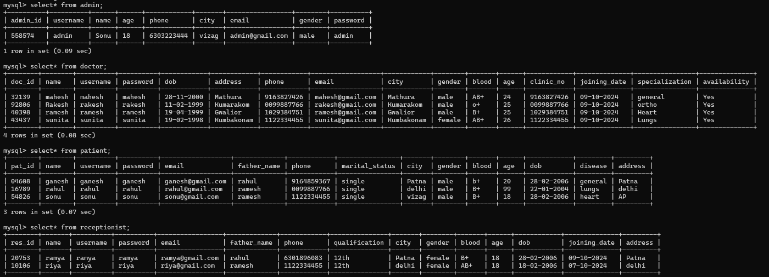

**ARCHITECTURE AND DESIGN**

The architecture of the Hospital Management System (HMS) defines the structure, design patterns, and components to be used for efficient operation, scalability, and security. The system follows a layered architecture, which separates presentation, business logic, and data management, making it easier to maintain and extend.

**ARCHITECTURE DIAGRAM**

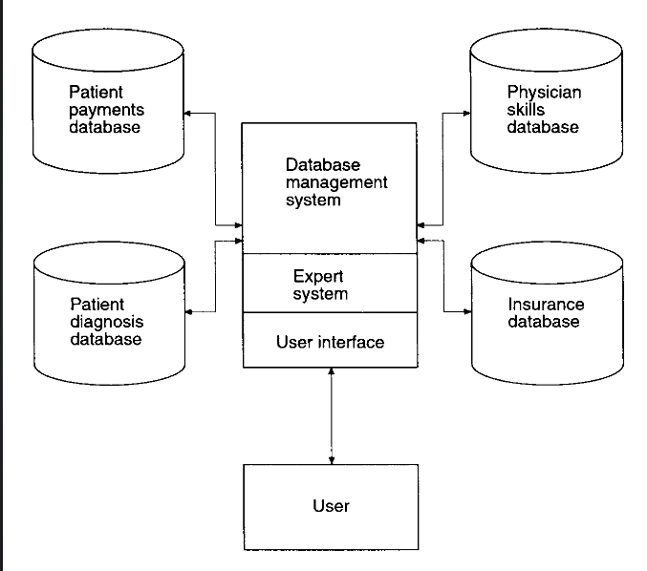

**UML DIAGRAM**

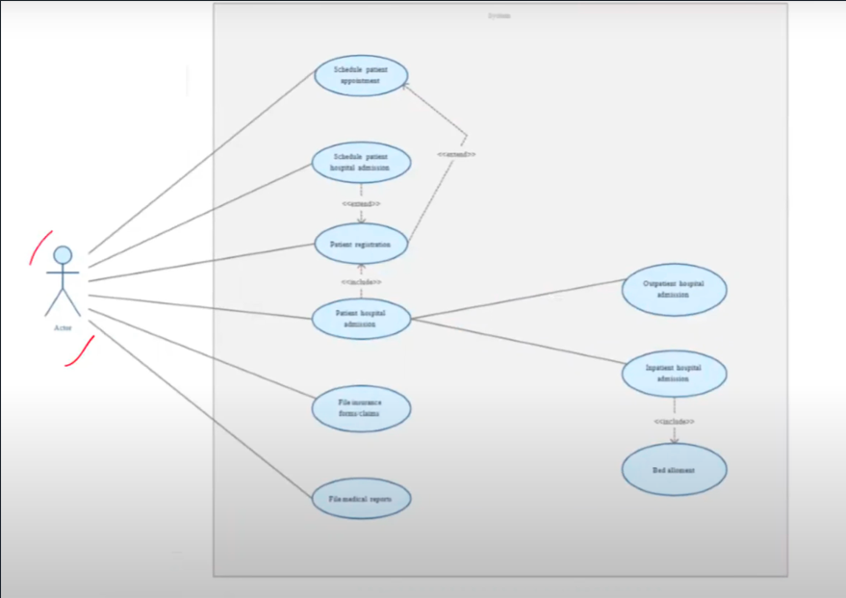

**USE CASE DIAGRAM**

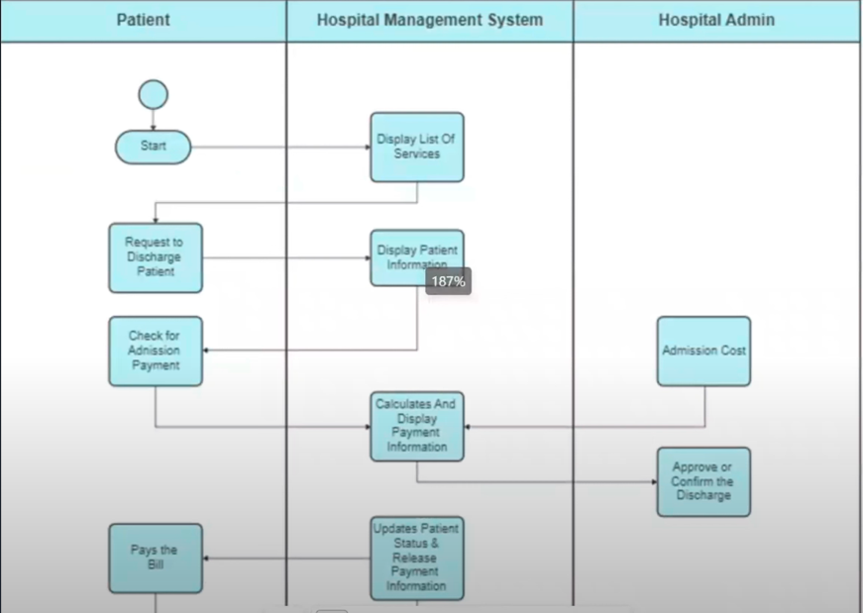

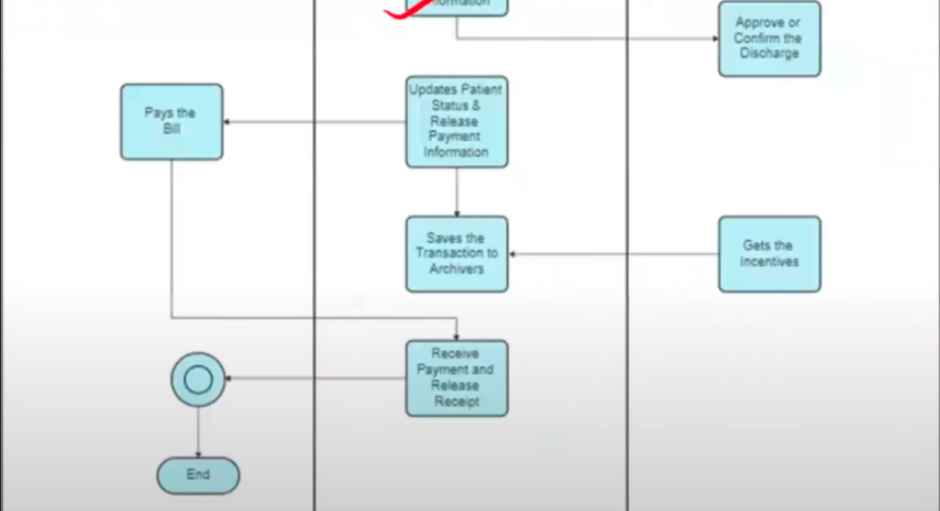

**IMPLEMENTATION**

Implementation of GUI Alumini project Connecting the database and the java using the my SQL Driver

**1.SET UP THE DEVELOPMENT ENVIRONMENT:**

* install Intelij idea and install the java files in it
* install my sql and set it up and prepare the database
* in java we have to import the libraries like sql,awt,swing
* we have to create the user interface using the java swing
* create the database in my SQL and insert all the tables
* connect database and java using the drivers

**2** **Graphical User Interface Using Java Swing:**

* It well designs login forms in which a user enters their credentials.
* Implementation of role-based access control shows the critical dashboards based on user roles (Admin, Doctor, Receptionist, Patient).

Admin Dashboard:

* Admin must perform add, edit, delete, and view user details (doctors, patients, receptionists).
* Doctor, Receptionist, and Patient Dashboards:
* Each of them will display role-specific functionalities focusing on appointment management and profile updates.

### **3** **Testing and Debugging**

* Conduct unit testing for each functionality, such as user registration, appointment scheduling, and record updates.
* Test role-based access to ensure each role only has access to the intended features.

**CODES**

**Connection**

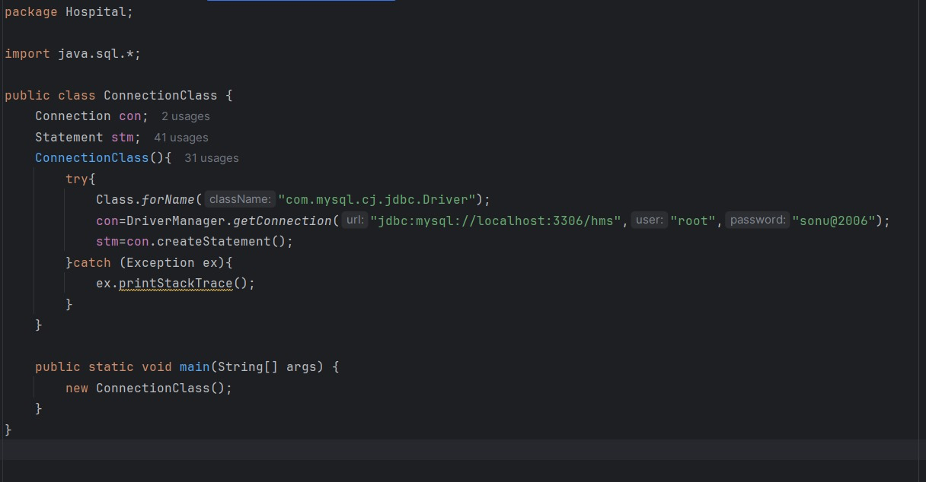

**LOGIN**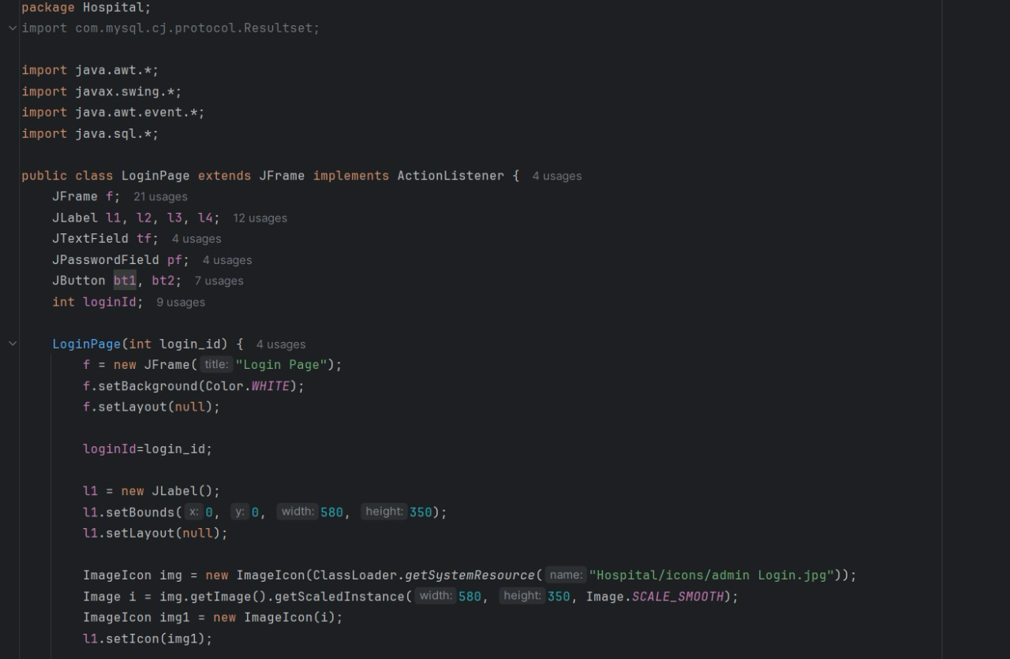 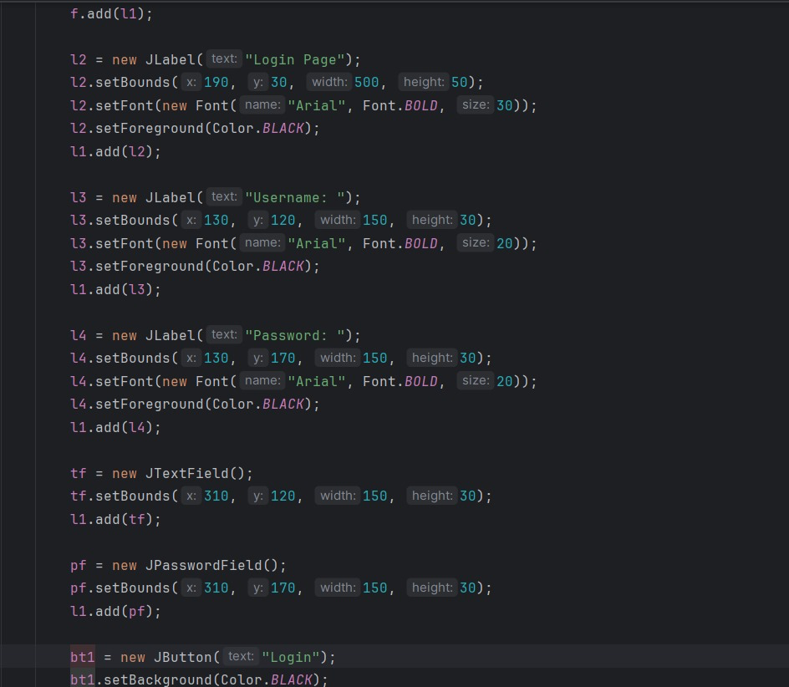 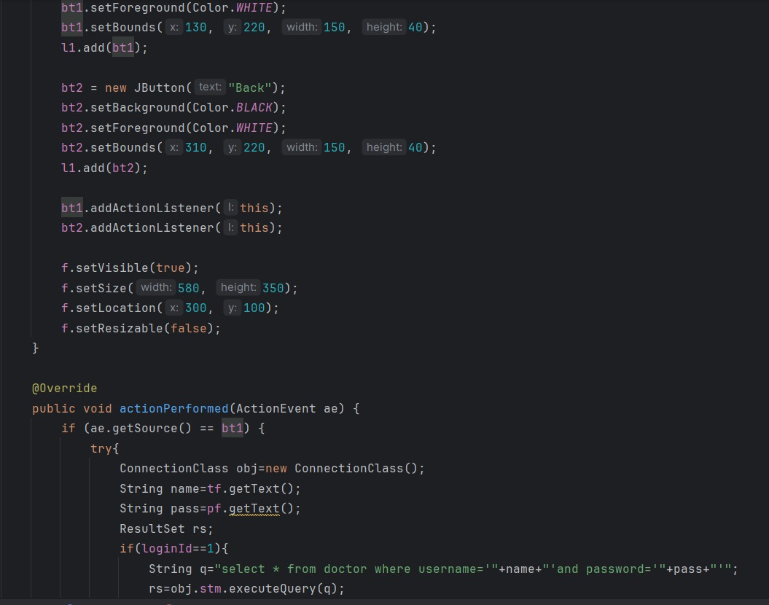 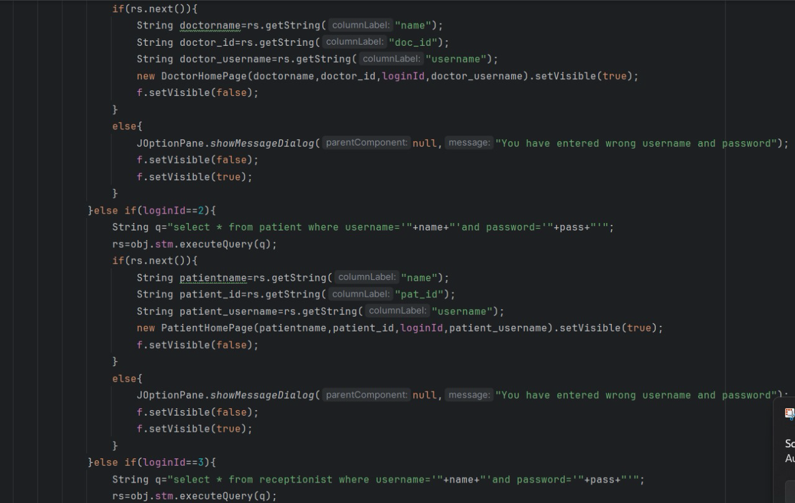 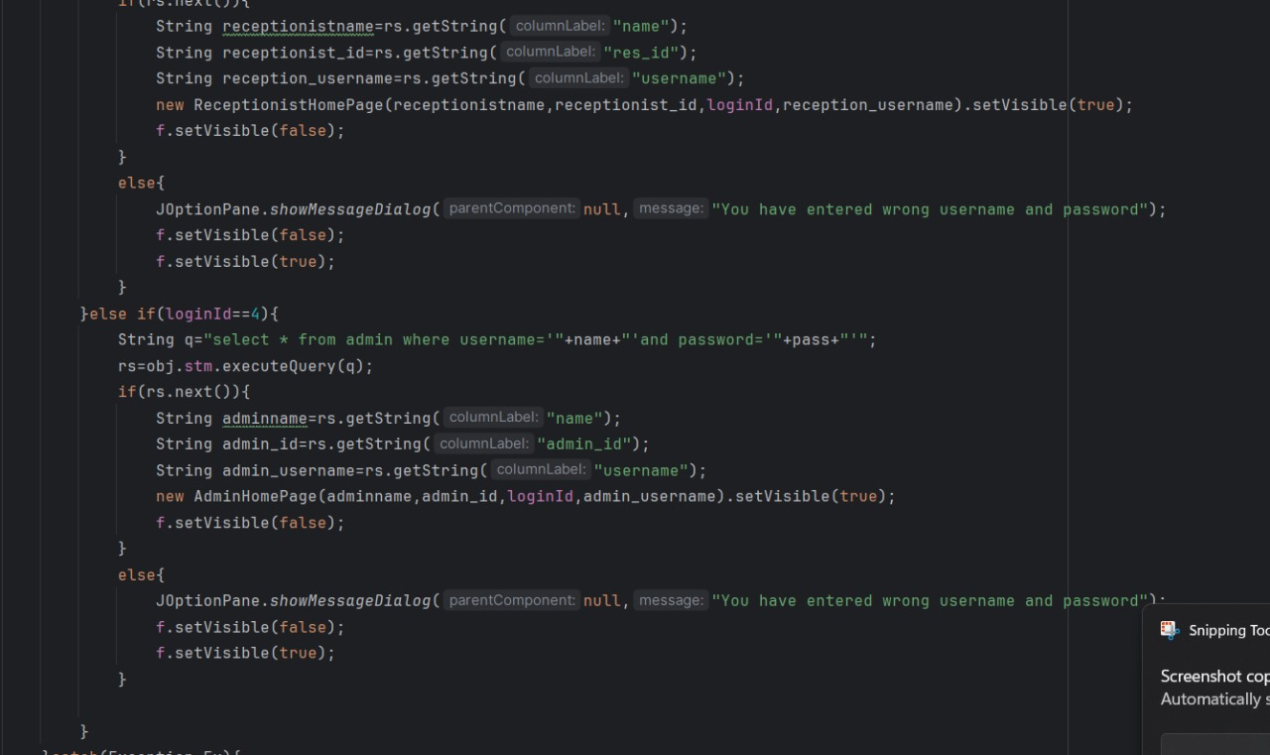 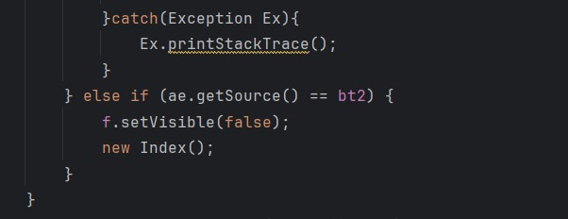

**INDEX**

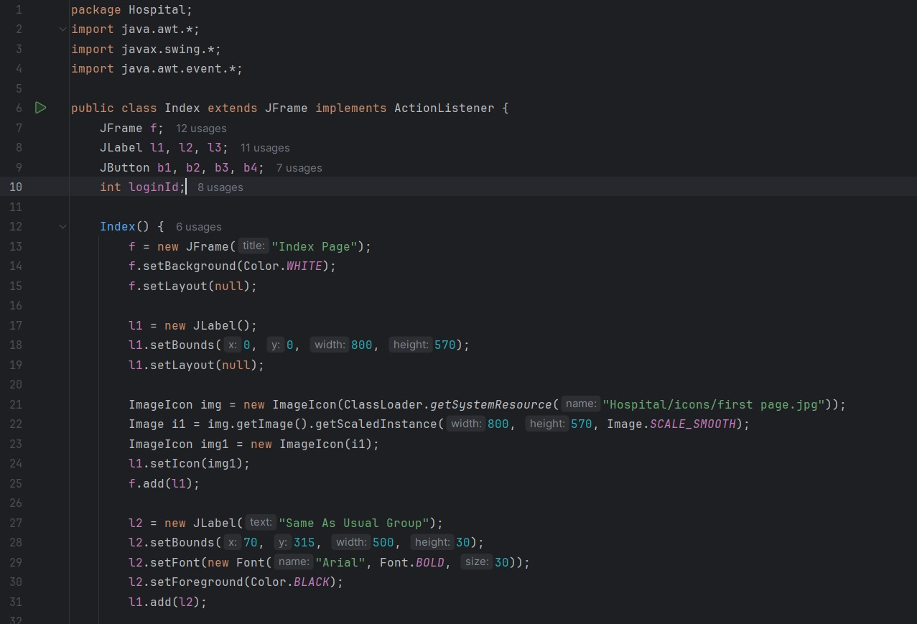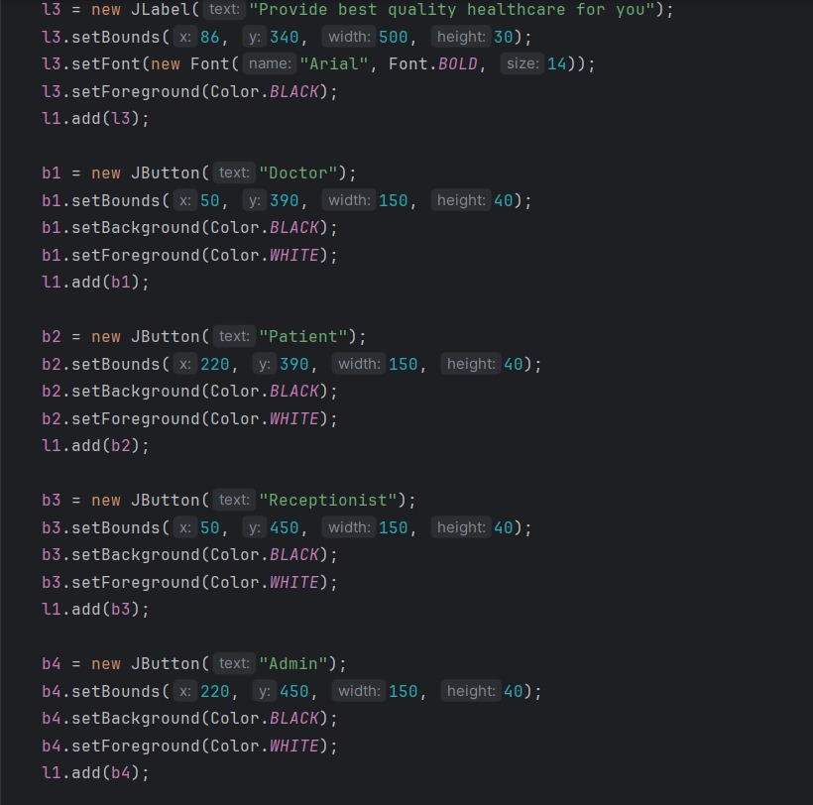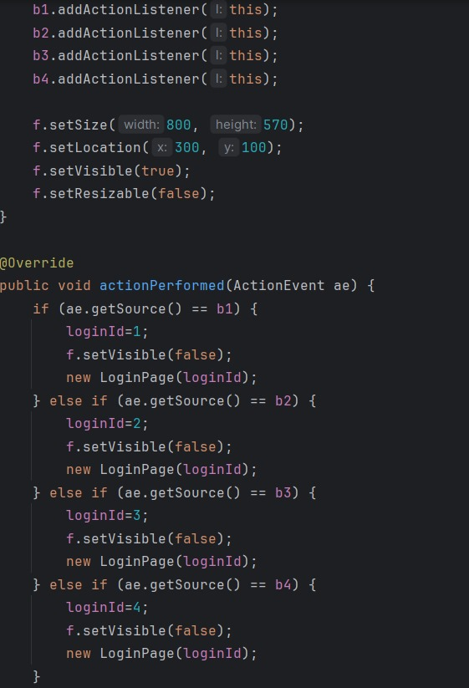

**HOME PAGE**

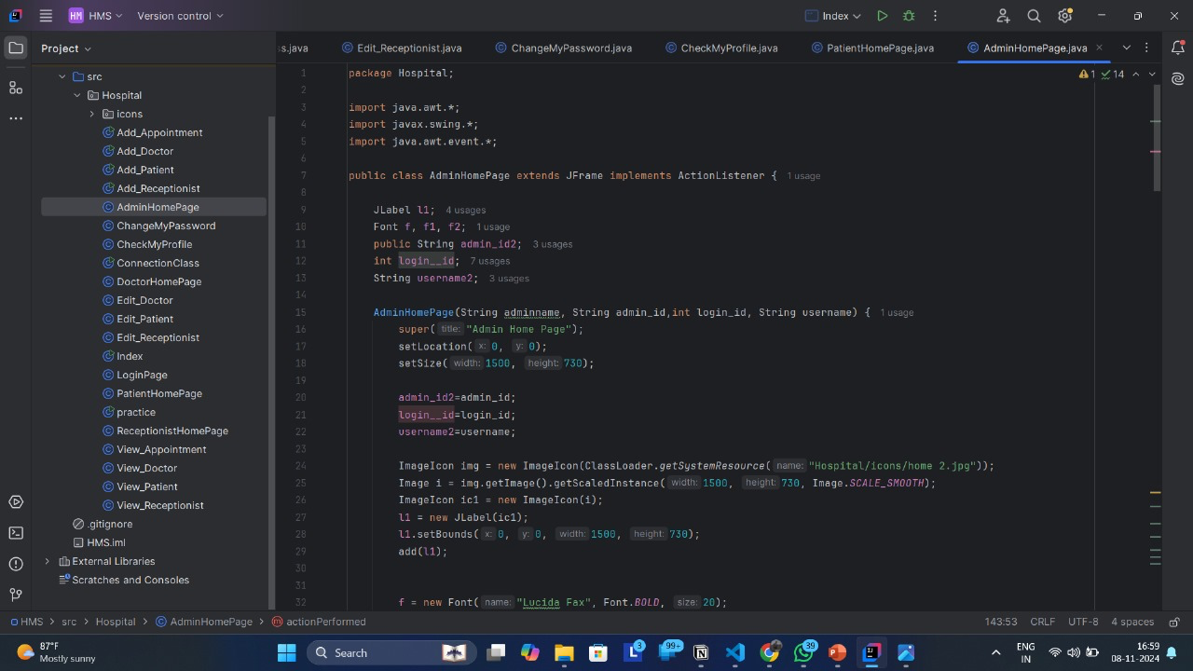 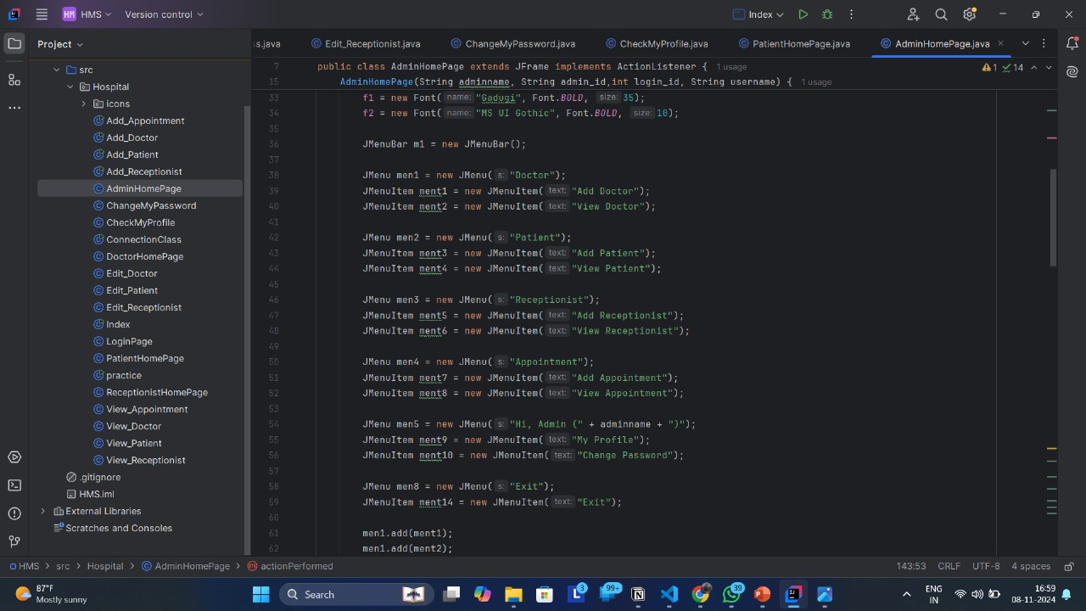 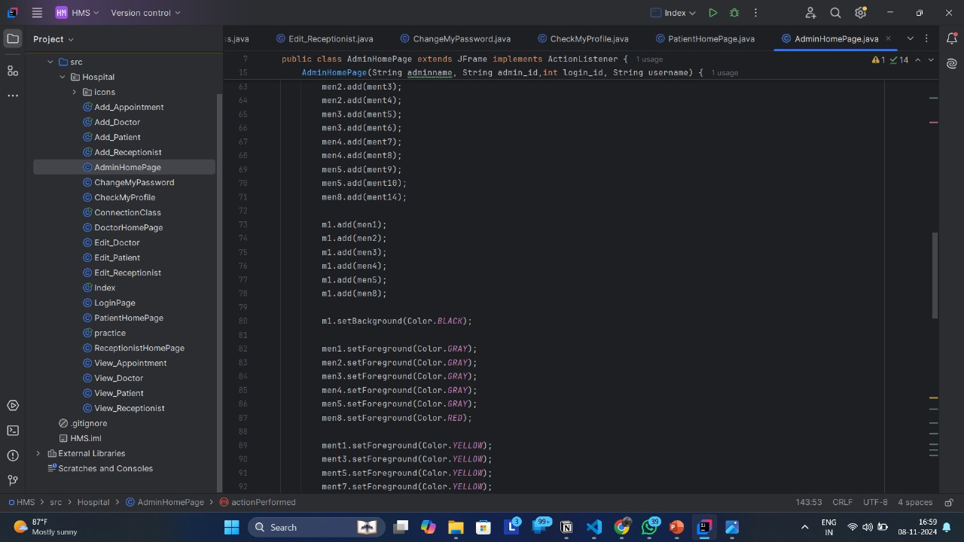 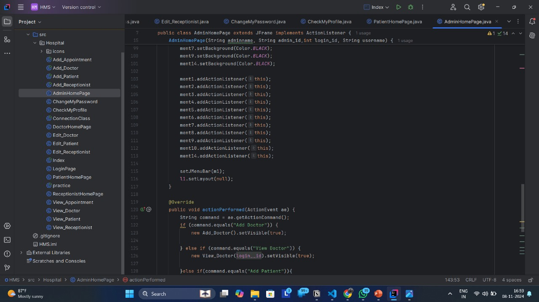 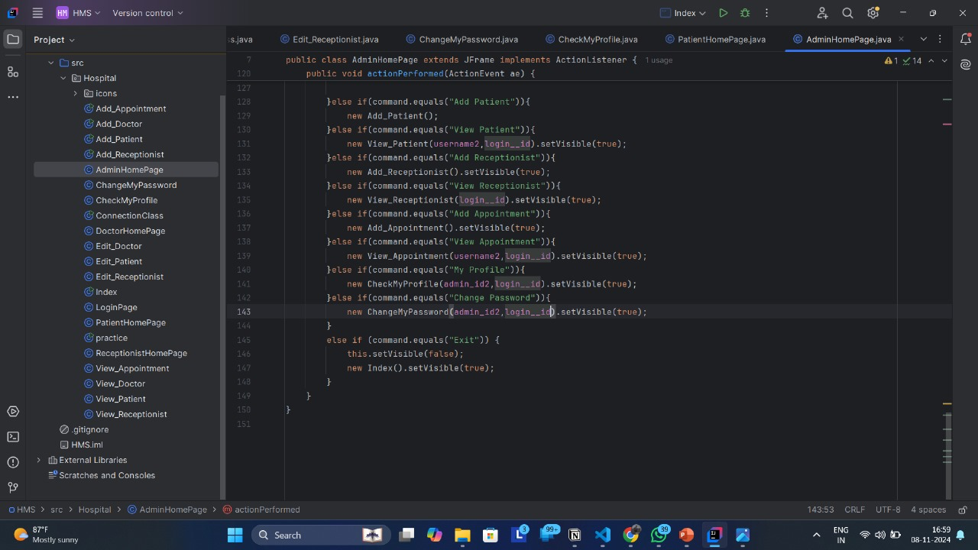

**ADDING THE ACTORS**

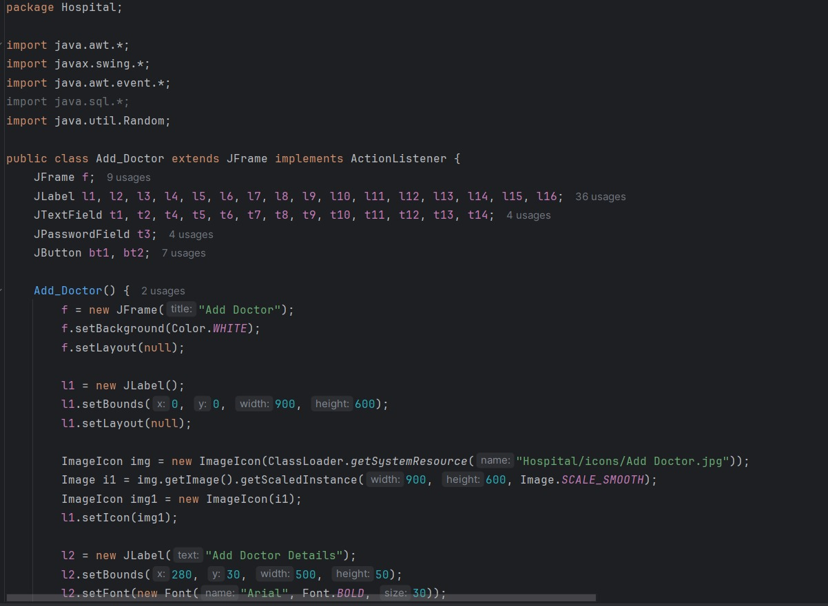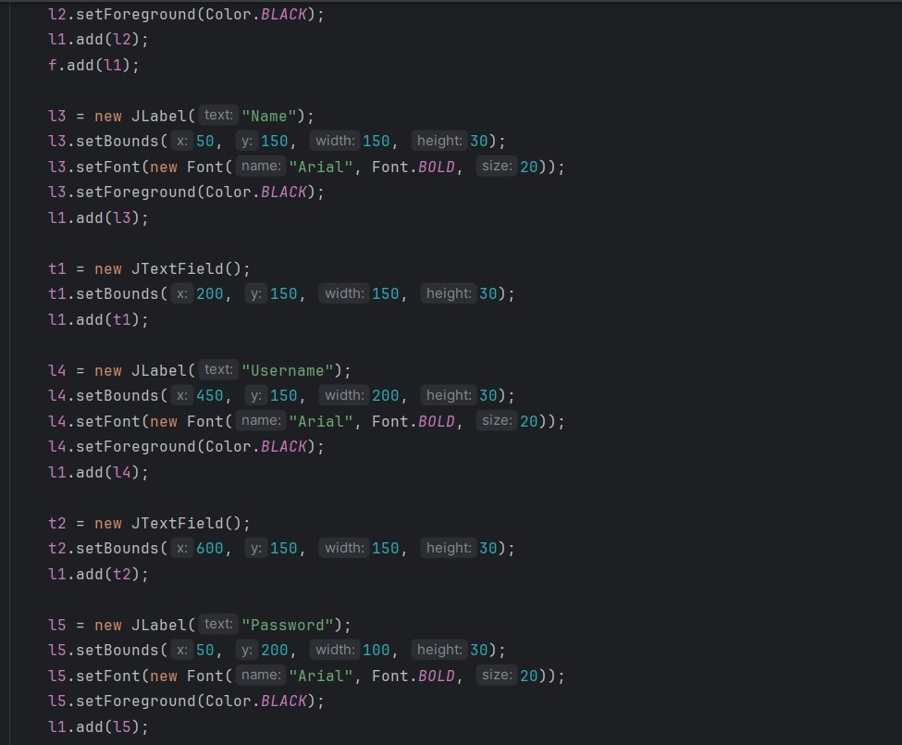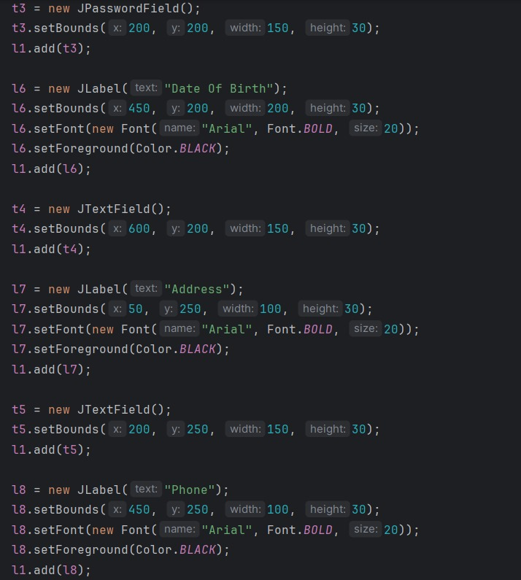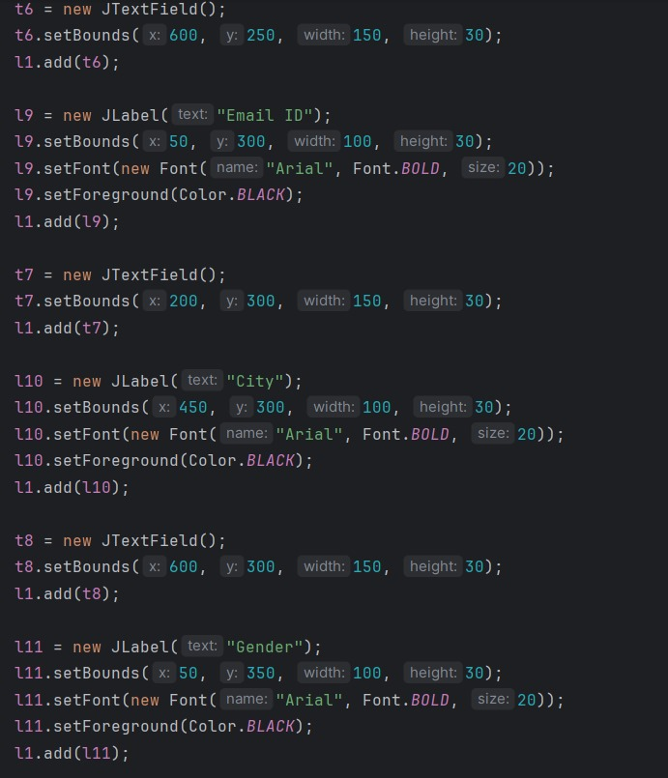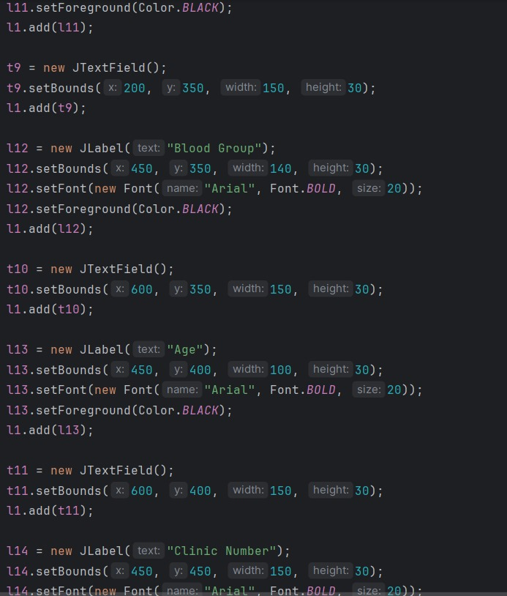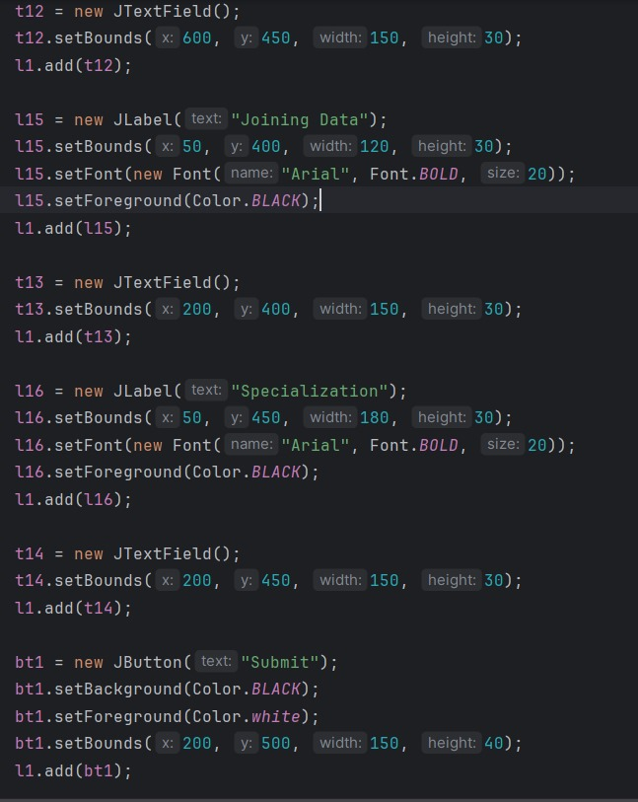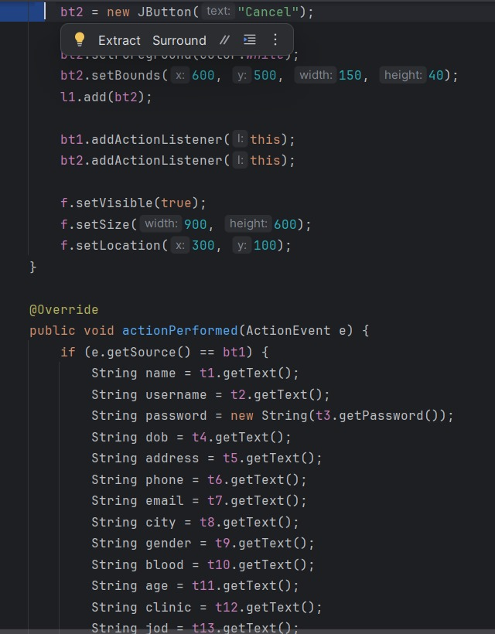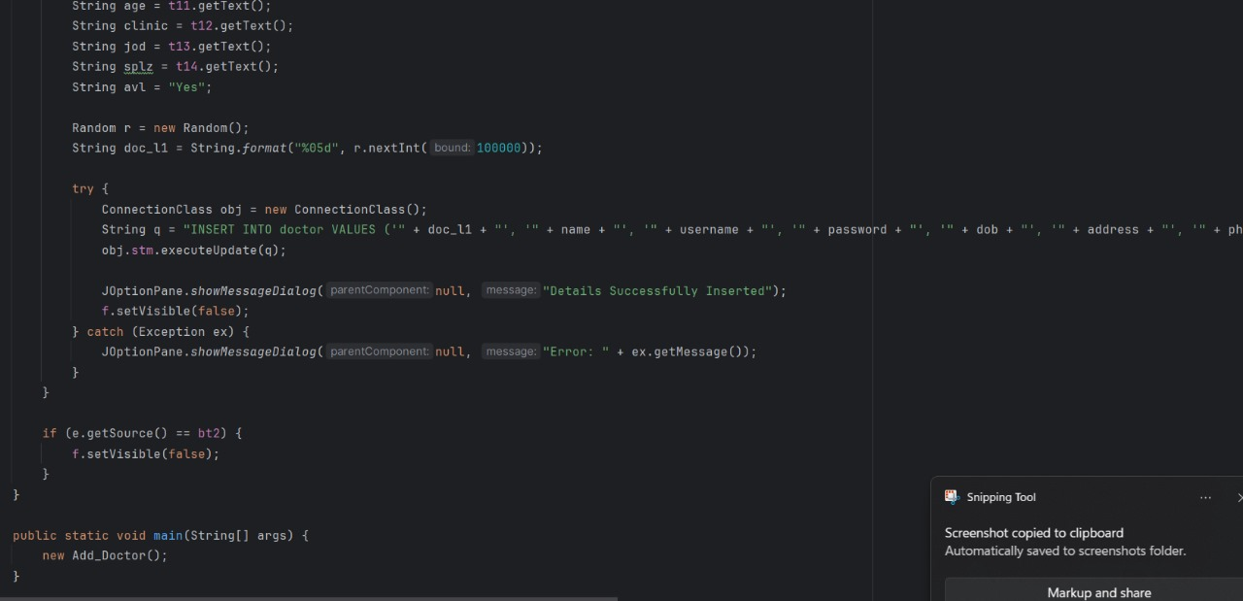

**VIEW ACTORS**

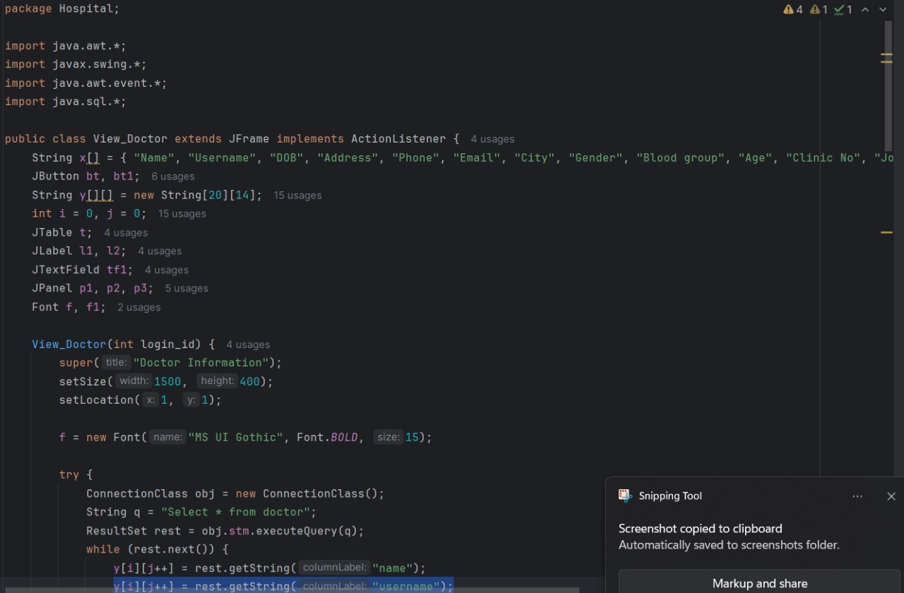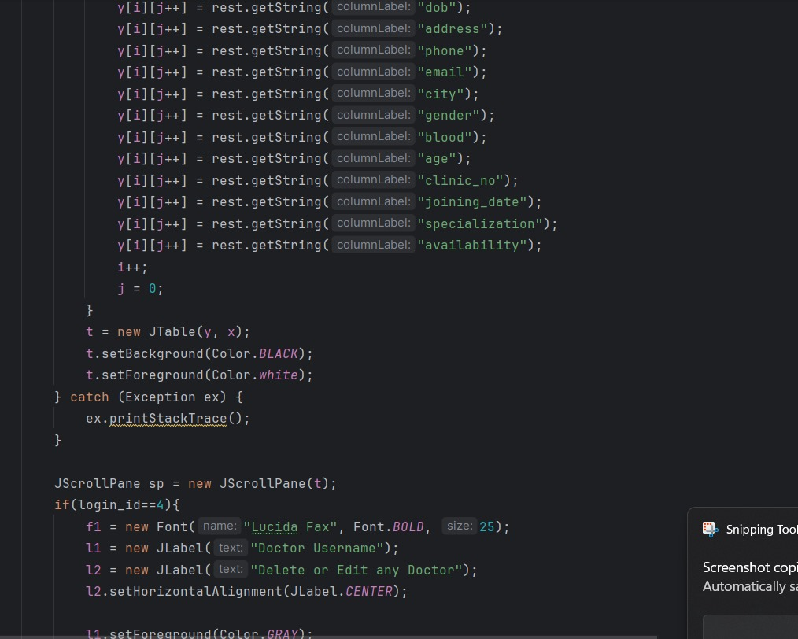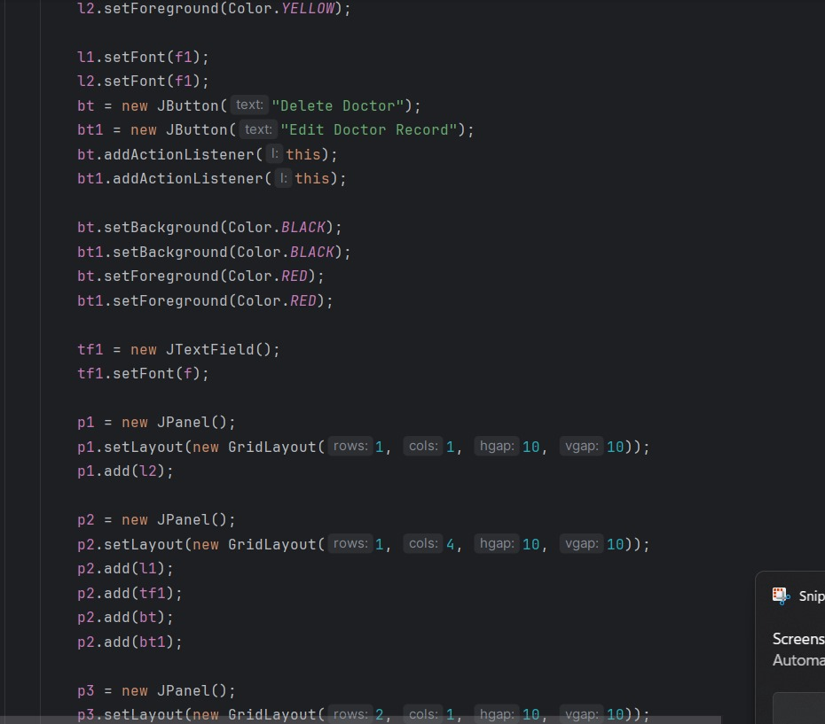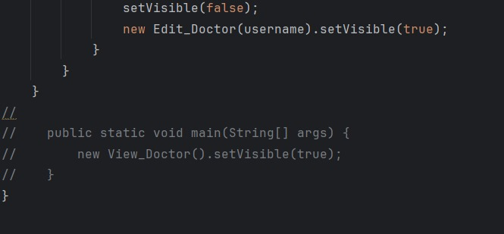

**EDIT**

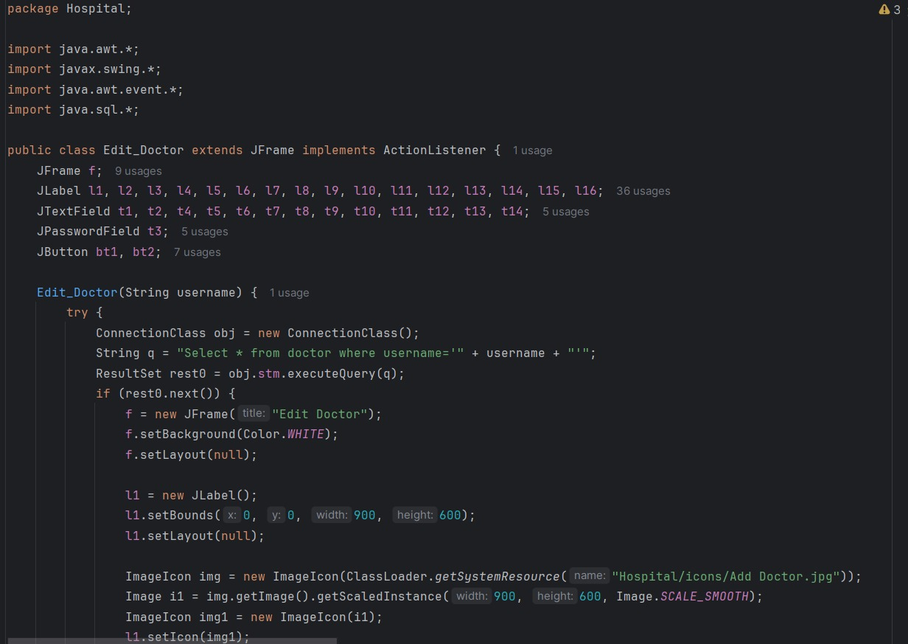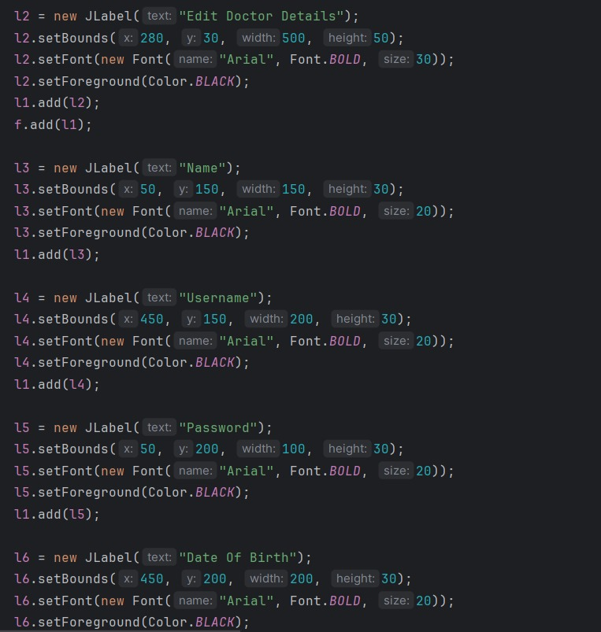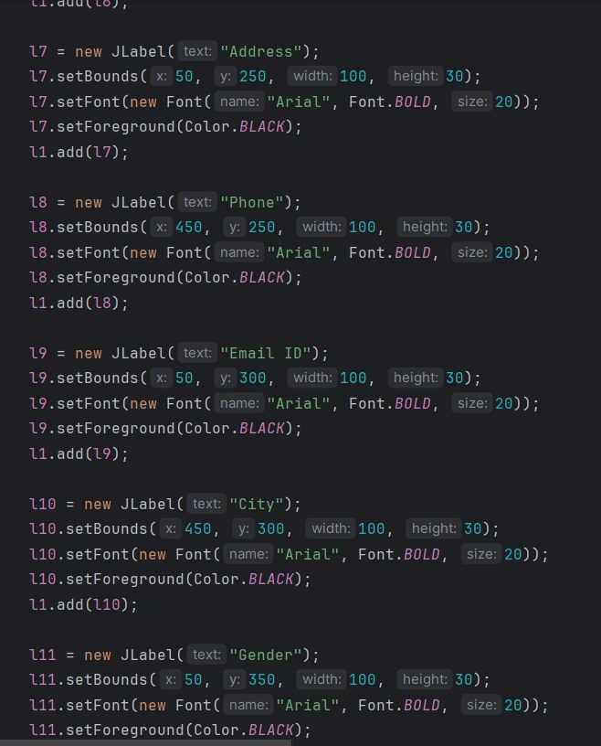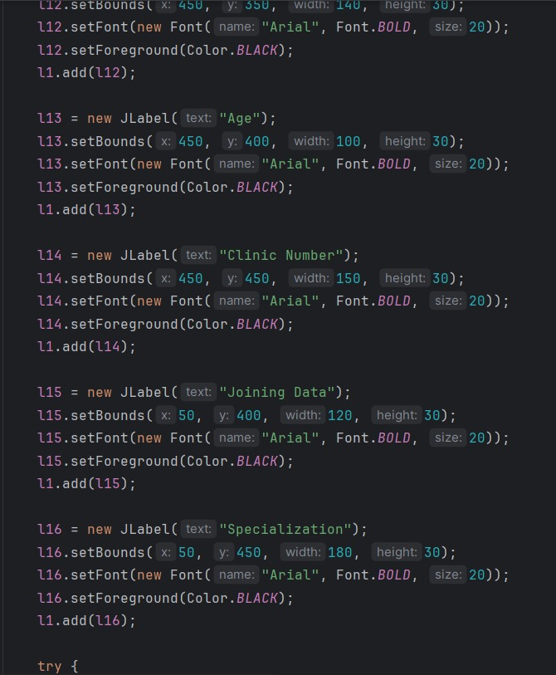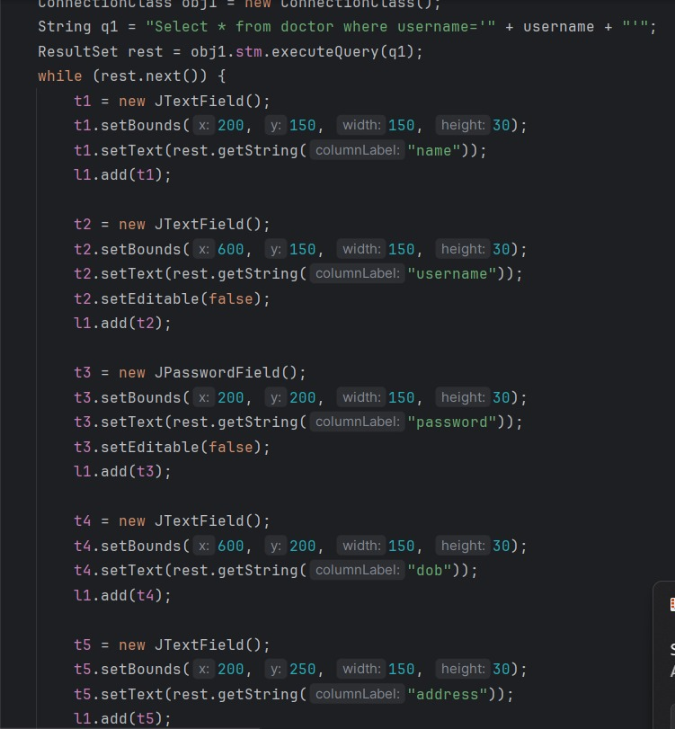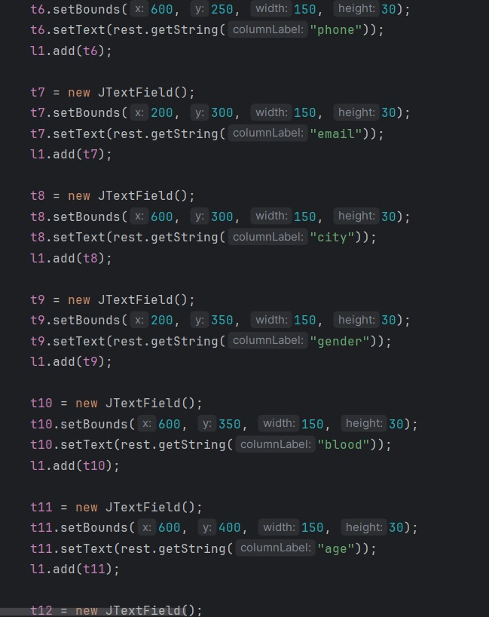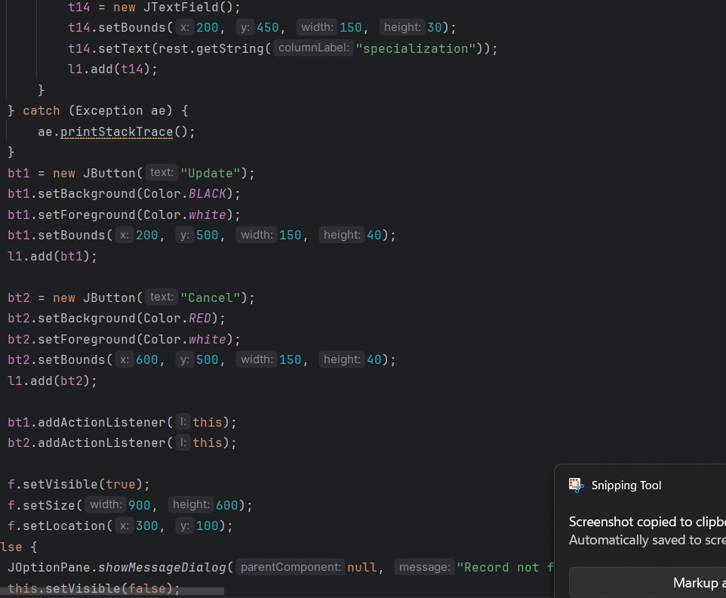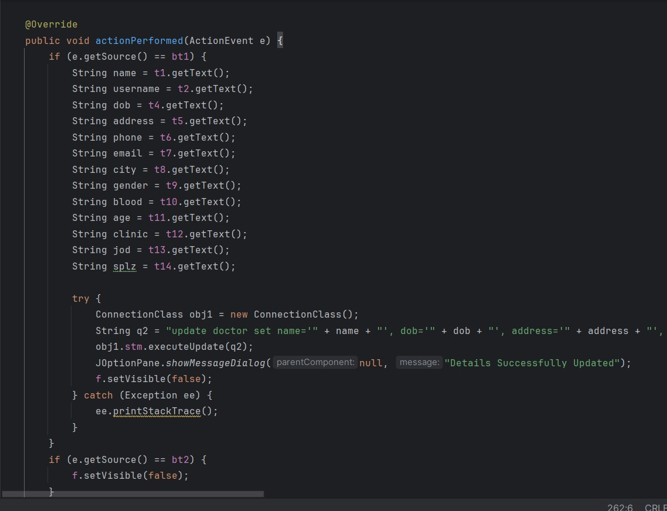

**VIEW PROFILE**

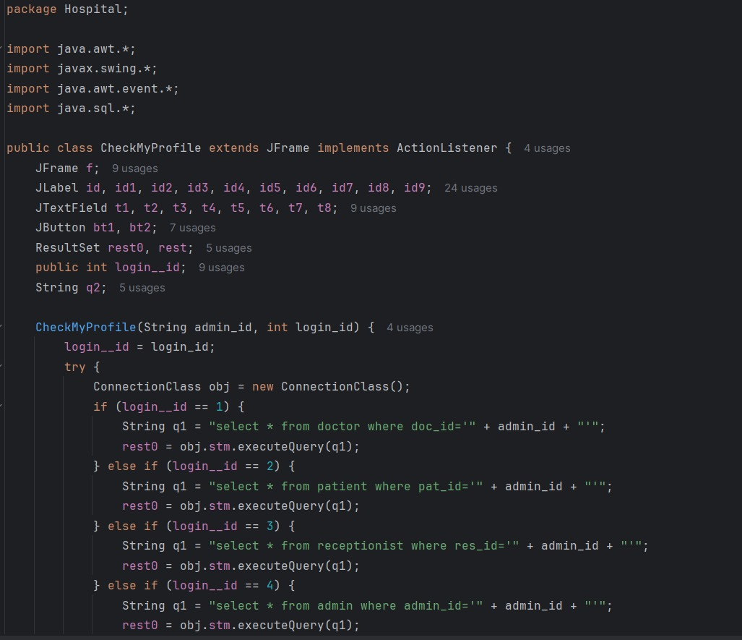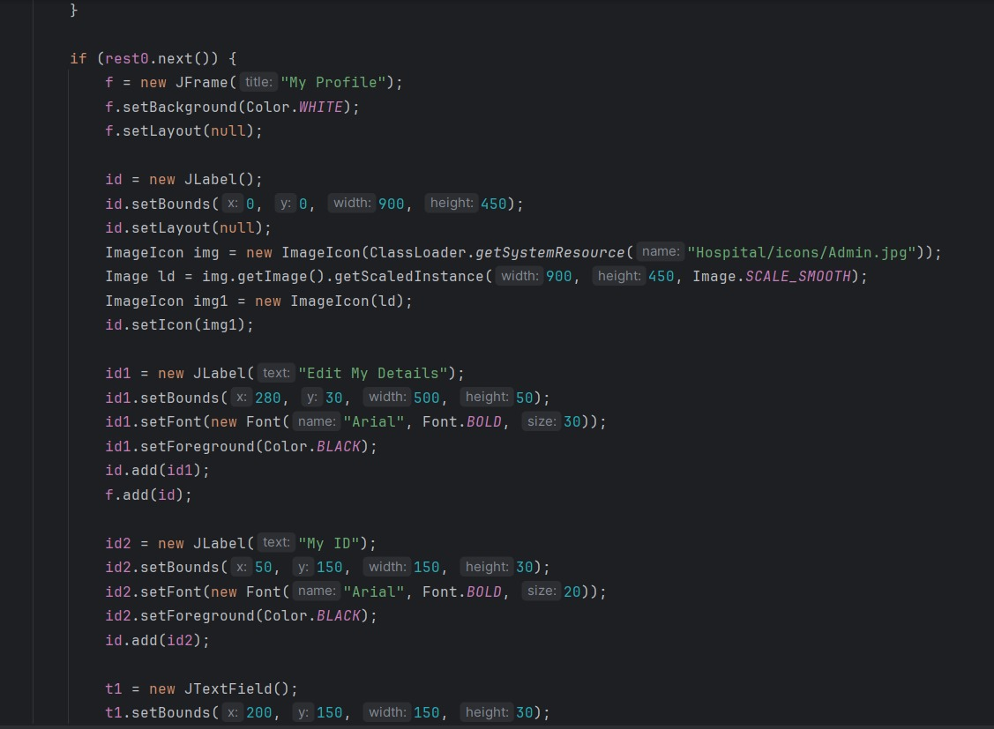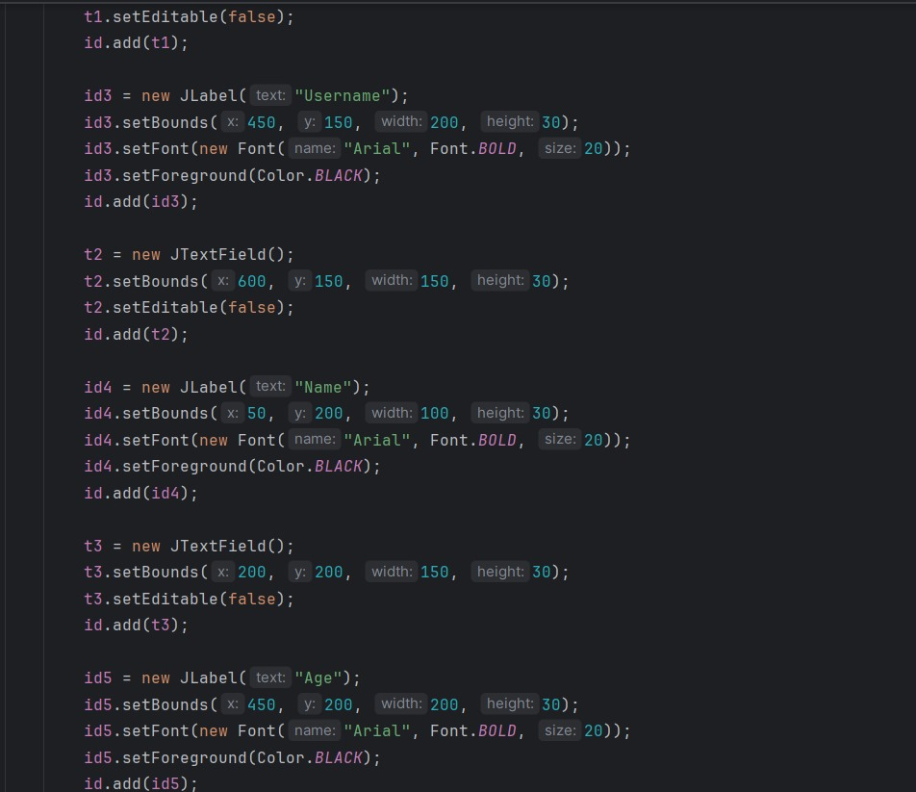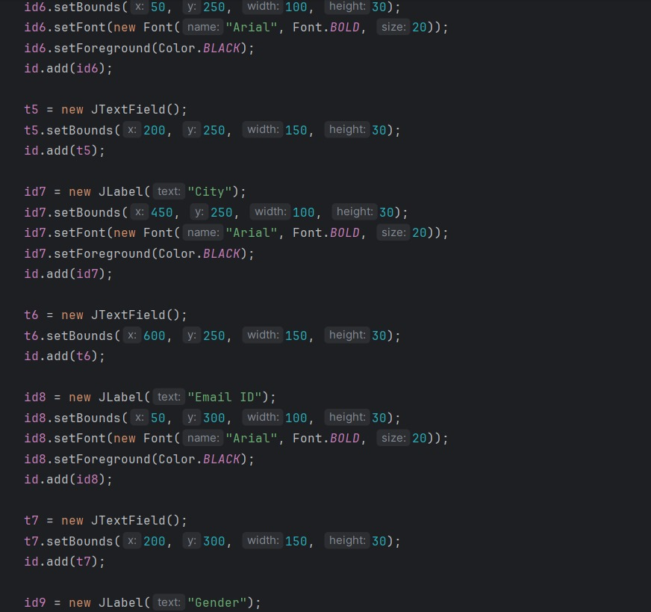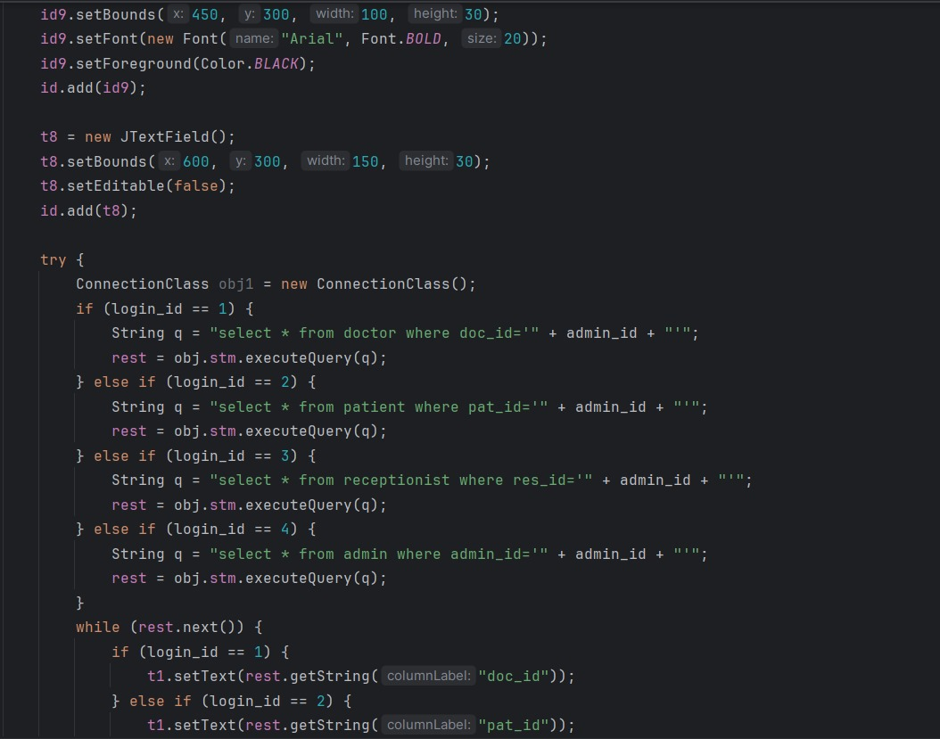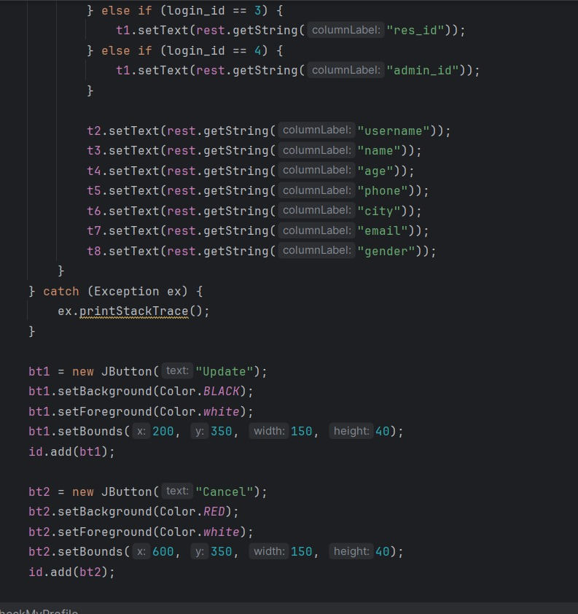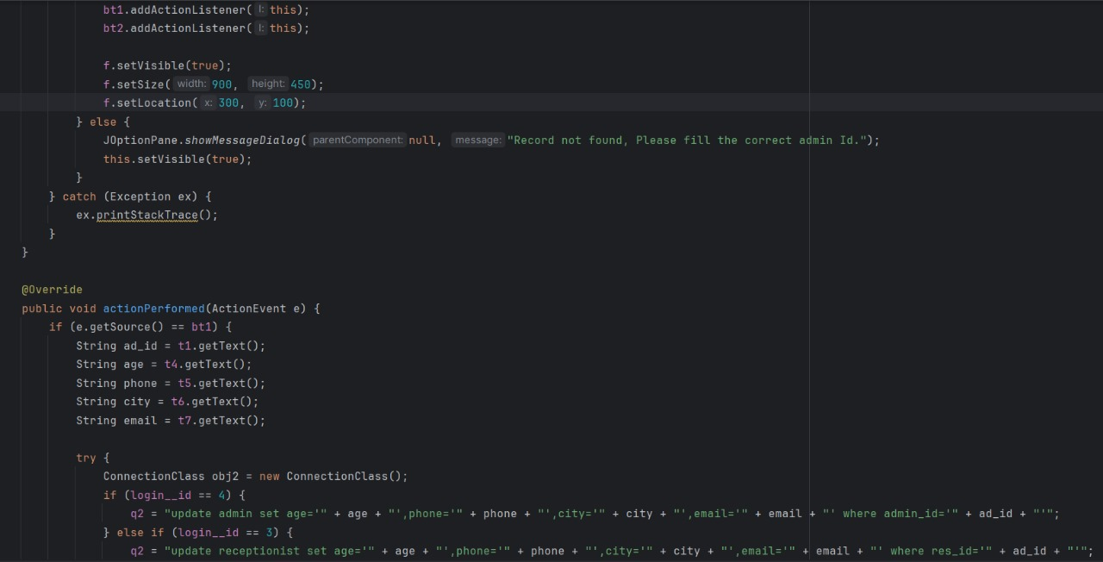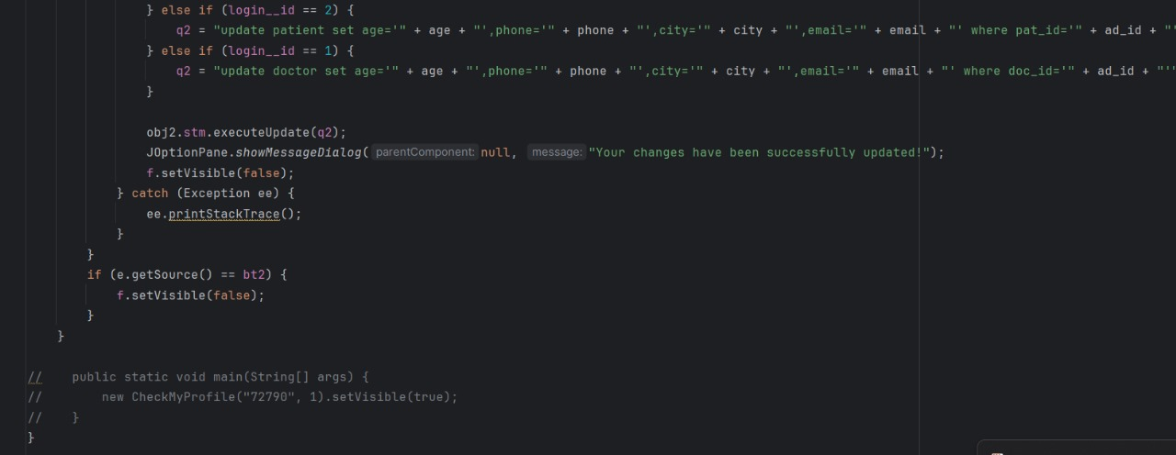

**CHANGE PASSWORD**

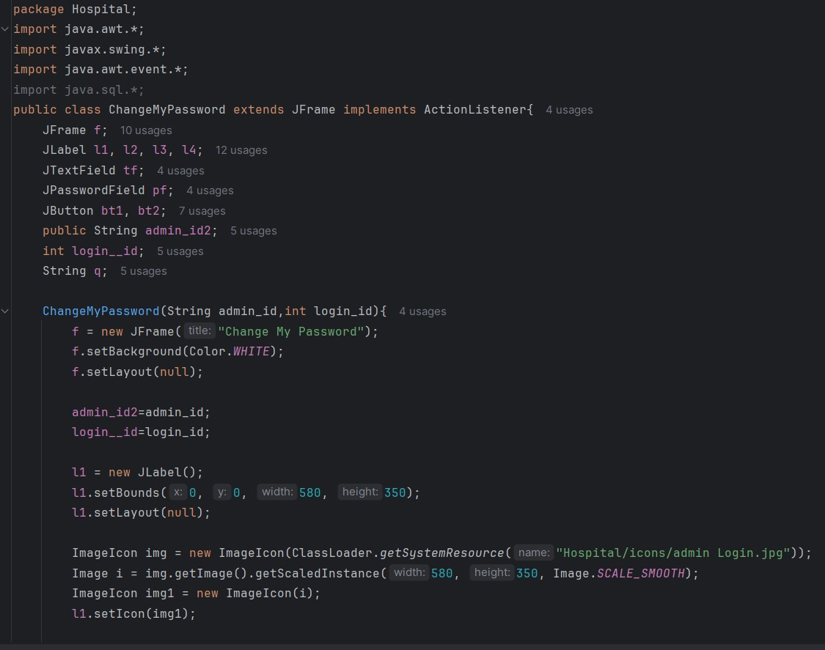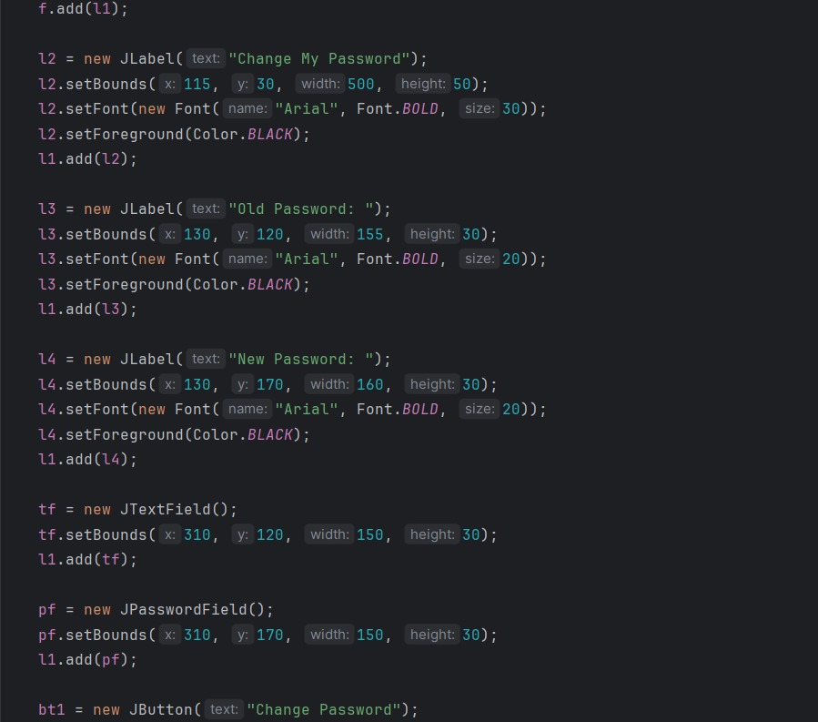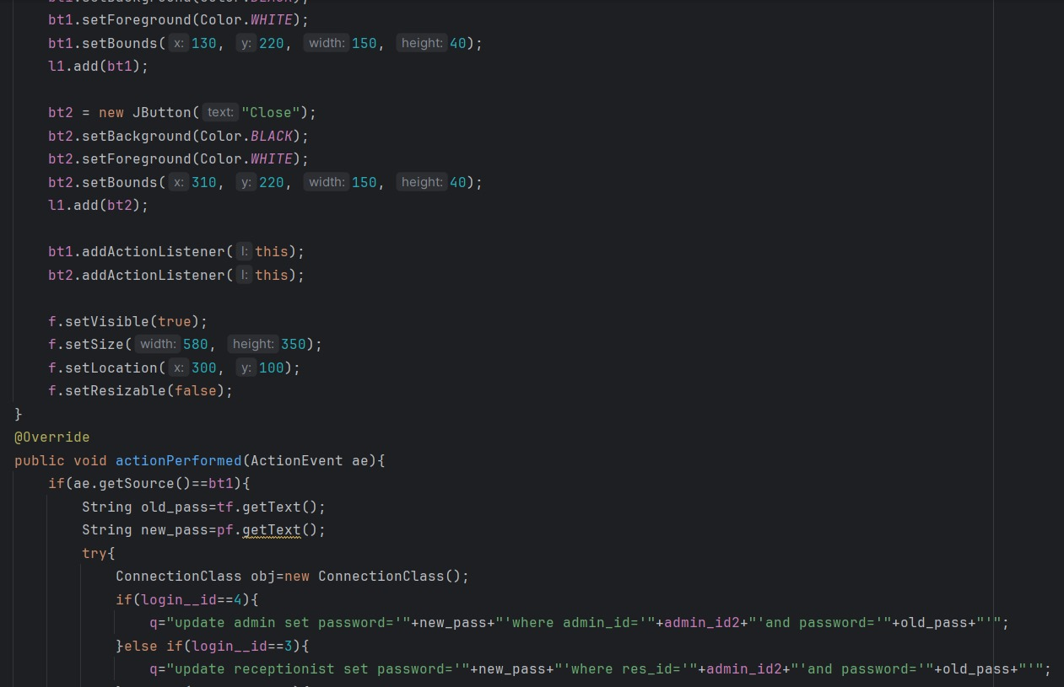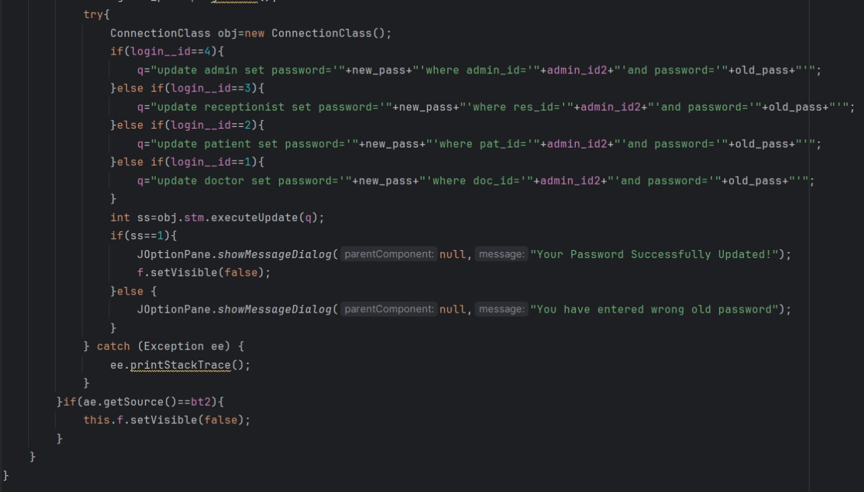

**OUTPUTS**

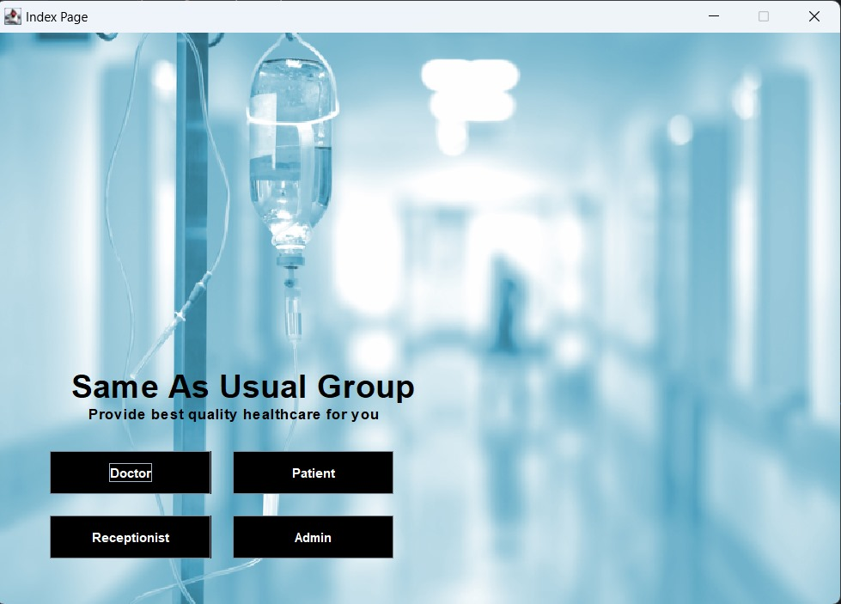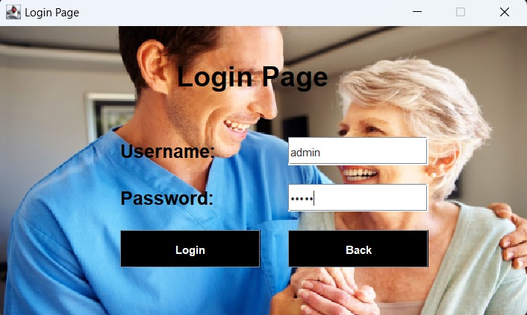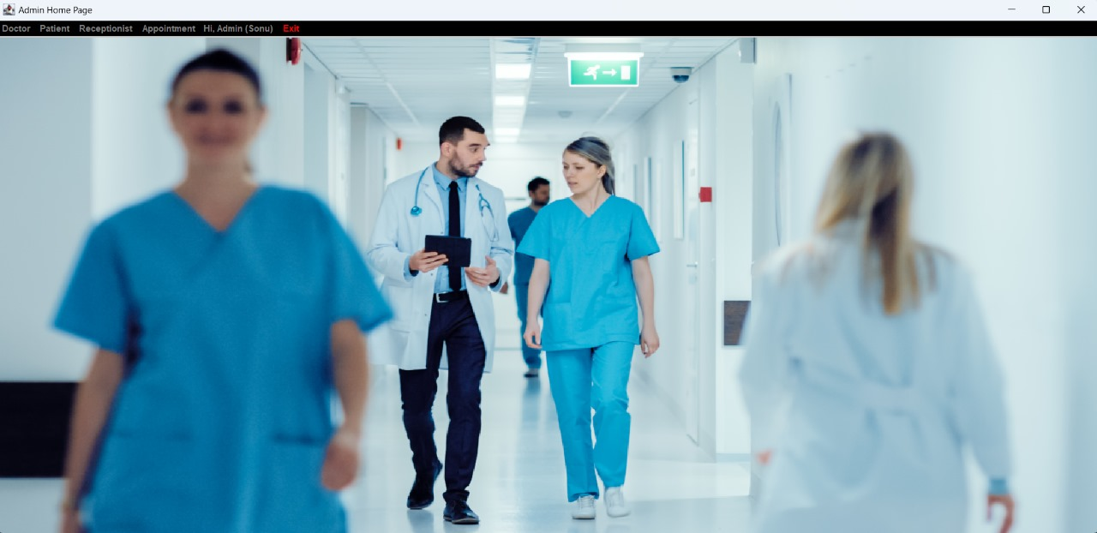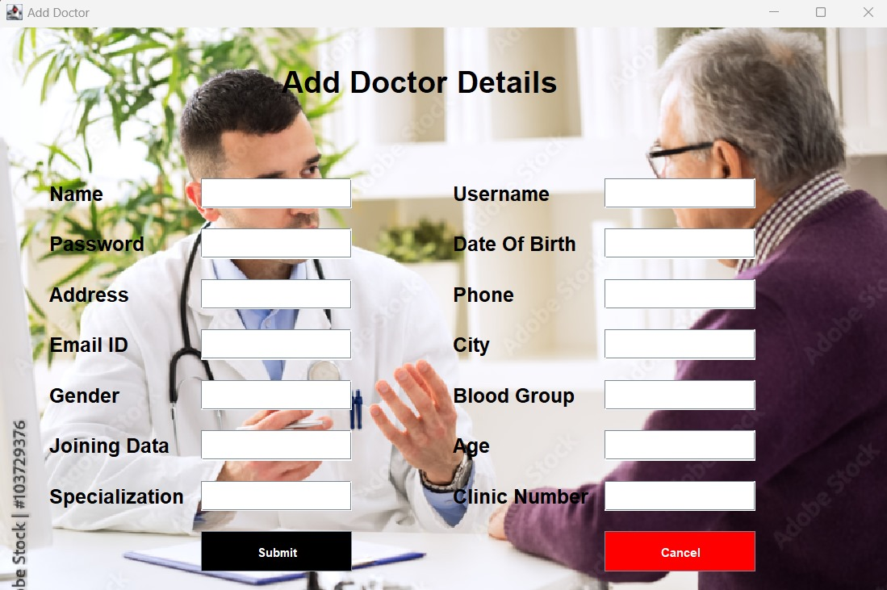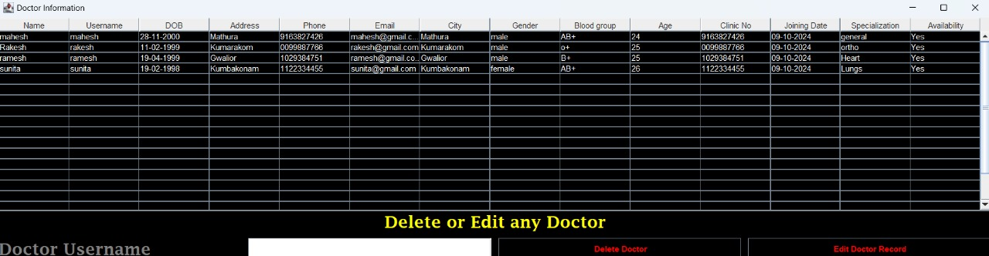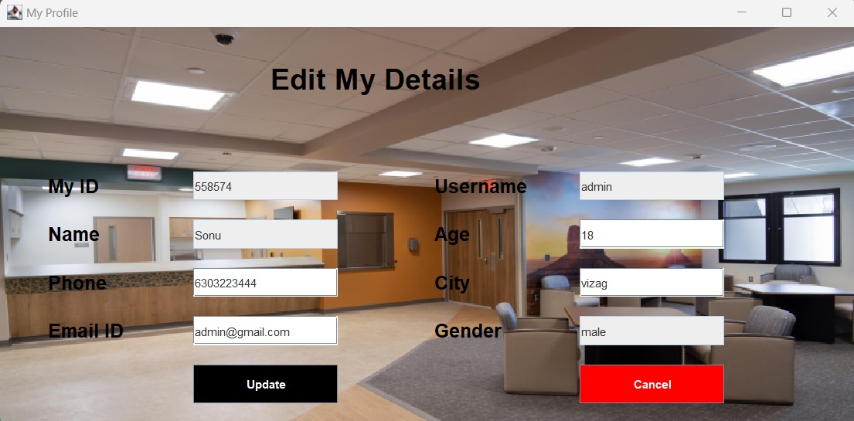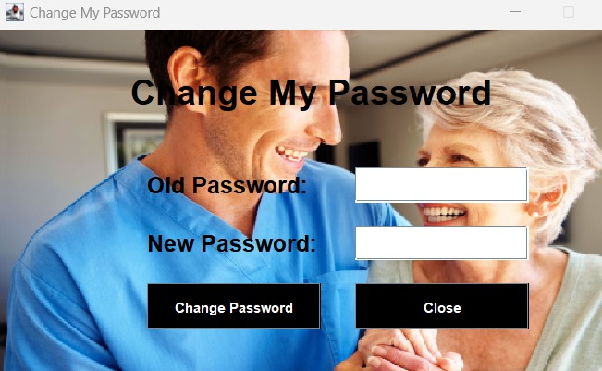

**EXPERIMENTAL RESULT AND ANALYSIS**

**Usability Evaluation**: Goal: Check the system's function that is the user's convenience per customer. Findings: Almost all participants feedback was positive and the system is not “rocket science”, some others needed help from the instructions to get through. Indeed, it was the greatest oversight was the case of oversimplification of the concept.

**User Satisfaction Survey:** Goal: The measurement of the degree of usability and the quality of a software application. Findings: Primarily to the positive among the doctors and patients who belong to the group that came up with the best feedback. The receptionists and users were the ones who said that one of them (the faster one) who was the other suggested the other more shortcuts than the first one made little use of the system

**System Performance Evaluation:** Goal: Test the fullest potential of the system's speed and efficiency under shocking conditions. Findings: It was predetermined to run the tests on systems that the output was going to be relatively high, however the system lagged a bit on the heaviest workload out of the others. The optimization process is coming, no worries.

**Data Collection and Analysis**: Goal: The collected information will be chosen for the learning process of surveys, tests and logs. Takeaway: In most of the cases it can be easily adapted by the user but still, components that cause longer time consumption and the times a user has to go through the routine tasks should be improved.

**FUTURE SCOPE**

**User Interface Enhancements:**

We have improved the interface greatly according to the feedback gotten from users. We have put in place quick-access buttons that give common functionalities and made the menus less confusing and straightforward. This brings about user friendliness and efficiency of the system.

**New Mobile App:**

We launched a mobile application for patients and the health staff. This app is permitted to make appointment bookings and provides admission to medical records through smartphones. The predominant idea here is to make management of healthcare easier to all parties concerned.

**Better reporting tools :**

New reporting features were introduced to the hospital administrators. Such tools offer many kinds of insights about what is going on within a hospital, such as how resources are being allocated and who sees the patients. This will help the management to make more informed decisions pertaining to processes in and out of hospitals concerning patient care.

**CONCLUSION**

The Hospital Management System has efficiently managed the activities in the hospital through centralizing the patients' records, scheduling of appointments, and other main functions. Specific roles of Admins, Doctors, Receptionists, and Patients, the system is well customized to improve efficiency while ensuring that the critical information is accessed securely. From the usability feedback, it is evident that the system is user-friendly with slight improvement areas in navigation and task shortcuts. The performance tests determine whether the system is reliable; the optimisation plans, to handle heavy loads better, further validate that the system workable. The whole system can serve as a wonderful base for the digital management of hospitals and will provide even more abilities with respect to using it when telemedicine support is incorporated into it along with enhanced reporting and mobile apps. The technology itself will demonstrate how health management could be simplified and how staff in hospitals and patients benefit from the system.

**REFERENCES**

**Books and Journals**

* Kaur, S., & Bhardwaj, R. (2015). Hospital Information Systems: A Review of Literature. International Journal of Computer Science and Technology, 6(2), 100-105.
* Tan, J. K. H. (2005). E-Health Care Information Systems: An Introduction for Students and Professionals. Jossey-Bass.
* Wager, K. A., Lee, F. W., & Glaser, J. P. (2009). Health Care Information Systems: A Practical Approach for Health Care Management. Jossey-Bass.

**Research Papers**

* Chavan, S., & Babar, S. (2017). Design and Development of Hospital Management System. International Journal of Research in Engineering, Science and Management, 2(4), 76-80.
* Smith, M., & Eloff, J. (2005). Healthcare Information Security and Privacy: Challenges and Solutions. Computers & Security, 24(1), 31-39.